**Hands-On: Hello World RESTful Web Service**

**Objective**

Create a basic RESTful web service using Spring Boot that responds with a hardcoded message:  
**"Hello World!!"**

**Requirements**

| **Item** | **Value** |
| --- | --- |
| Method | GET |
| URL | http://localhost:8083/hello |
| Controller | com.cognizant.spring_learn.controller.HelloController |
| Response | "Hello World!!" |

**Implementation Steps: Create the Controller Class**

package com.cognizant.spring_learn.controller;

import org.slf4j.Logger;

import org.slf4j.LoggerFactory;

import org.springframework.web.bind.annotation.GetMapping;

import org.springframework.web.bind.annotation.RestController;

@RestController

public class HelloController {

private static final Logger LOGGER = LoggerFactory.getLogger(HelloController.class);

@GetMapping("/hello")

public String sayHello() {

LOGGER.info("START sayHello()");

String message = "Hello World!!";

LOGGER.info("END sayHello()");

return message;

}

}

**Update application.properties**

server.port=8083

**SME Notes / Explanation Section**

**What happens in the controller method?**

* When the client makes a GET request to /hello, Spring Boot calls the sayHello() method.
* This method logs **START** and **END** using SLF4J Logger.
* It returns the string "Hello World!!" to the client.

**Chrome Network Tab (F12):**

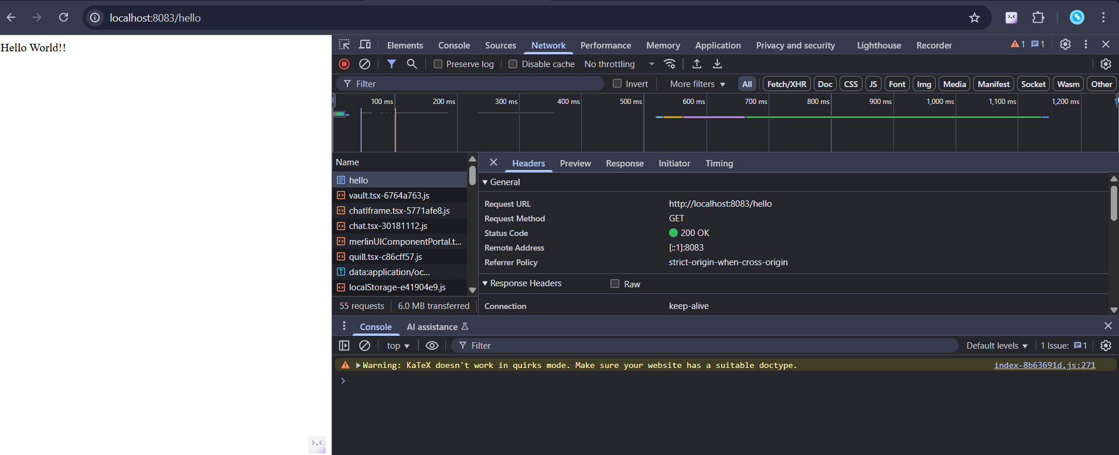

**POSTMAN OUTPUT:**

